Introduction
Through several projects we have experienced that a generic HW platform including basic peripherals, is suitable for a lot of different control and regulation applications.
For that reason we want to develop a basic embedded computer solution, which we will offer our customers as a cheap, flexible and very “time-to-market” friendly platform.

This basic embedded computer solution shall include both a generic HW board and a SW framework, which will enable us to have a given prototype running for demonstration in a very short time period.

The solution must of course supply the most basic functionality used in an embedded computer, moreover the solution must be extendable with new HW interfaces, such as new communication media, e.g. CAN bus, GSM modem etc.

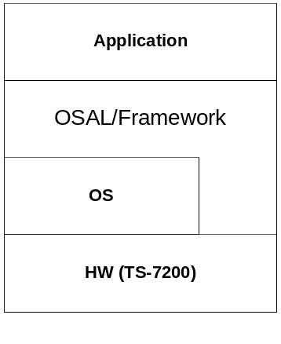
The system layers

Objectives
The objectives of the project are to:

- Apply real-time capabilities to the OS
- Verify and test the real-time performance of the OS run on the target HW.
- Design the SW framework and select a subset of the POSIX API to be used in the SW framework.

HW Platform
The HW candidate for the project is the TS-7200 SBC from Technologic systems.
The TS-7200 is a full featured SBC based on the ARM9 CPU and provides a standard set of on-board peripherals, including:

- 200 MHz ARM9 processor with MMU
- 32 MB of High Speed SDRAM
- PC/104 expansion bus
- 2 COM ports
- 10/100 Ethernet interface
- Compact Flash Card interface
- Watchdog timer, SPI bus

The TS-7200 is a cheap and flexible solution and includes the basics we are looking for. It includes the PC/104 expansion bus, which makes it highly flexible regarding extensions.

The TS-7200 is shipped with a Linux OS, TS-Linux – Based on the “Busy Box” distribution, installed on the internal flash. The TS-Kernel is based on the 2.4.26 Linux Kernel.

Problem domain analysis
The problem domain analysis is somewhat special because we are building a platform that will be part of a solution developed by the application programmer. However, since the platform must provide the basic building blocks for an RTS computer application, the problem domain analysis will focus on the characteristics of a RTS. The system must provide means for addressing and handling these characteristics.

Problem definition

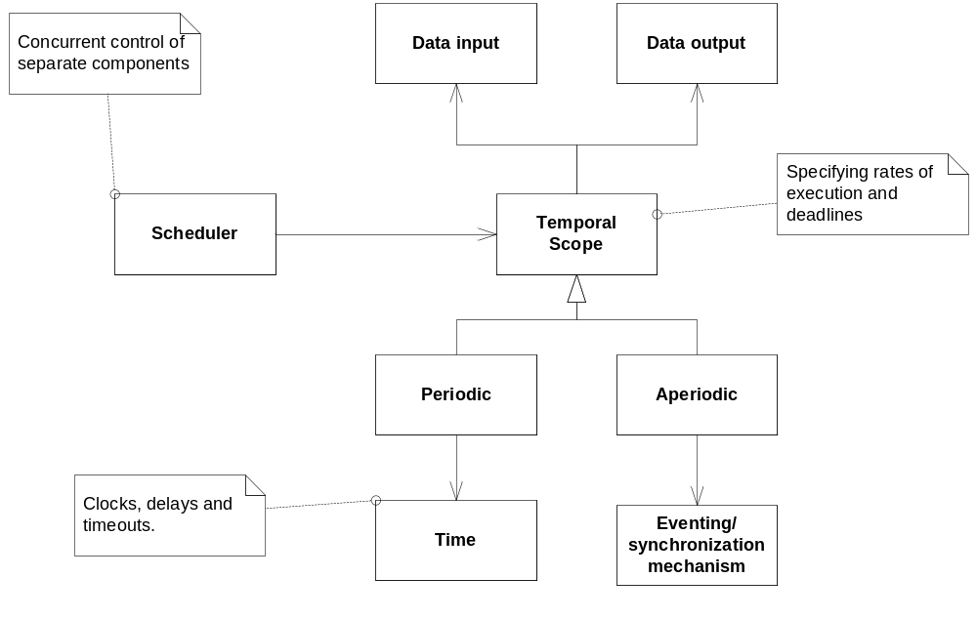

Logical view of the problem domain.

The problem domain consists of a number of temporal scopes which can be either periodic or a-periodic. These temporal scopes represent the timing requirements of the end application and the platform must abstract these temporal scopes. In order for the temporal scopes to meet their deadlines, they need to be scheduled in a deterministic manner. To handle periodic temporal scopes the platform must provide means for measuring elapsed time and delay the periodic processes until the next period begins.
The A-periodic temporal scopes are used to handle non-periodic external events and there is a need for synchronizing the processes with these events.
The running system interacts with the environment it controls, it reads some environment states and reacts accordingly by performing some action on the environment. This is abstracted by the DataInput and DataOutput classes.

In order to get real-time support, the kernel must support priority based pre-emptive scheduling. According to the documentation, the TS-Kernel is real-time capable through RTAI. The OS must be tested to verify the scheduling capabilities.

To support portability and to create a “simple” interface to the basics of a running embedded program, a software framework must be implemented. This framework consists of an OS Abstraction Layer and provides means for flexible communicating between individual components in the program.

The framework must supply interfaces for input and output of data to the application, e.g. access to the onboard GPIO, LEDs and data communication devices.

The framework shall be developed in C++ and encapsulate the rather verbose C API to the POSIX compliant OS interface.

Application domain analysis
The application domain analysis consists mainly of the identification of classes and interfaces abstracting the logical view from the problem domain analysis.

Temporal scopes:

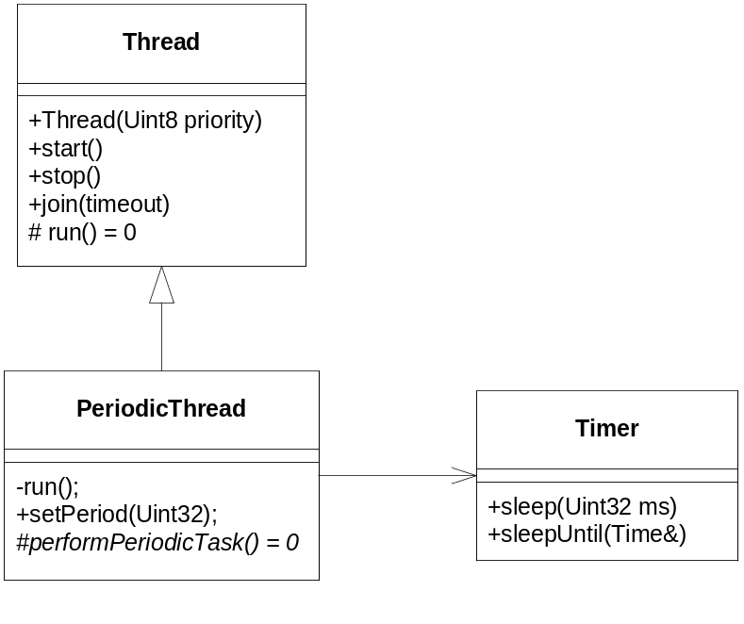
In order to support temporal scopes the Thread class is introduced. It wraps a single thread of execution and is scheduled by the OS scheduler.

Since it is the application which imposes the timing requirements on the threads running, each instance of the thread class is given a static priority during construction.

For periodic threads a Timer class is used to delay the thread until next period start. The delayUntil() method is used to delay the thread up until some time in the future.

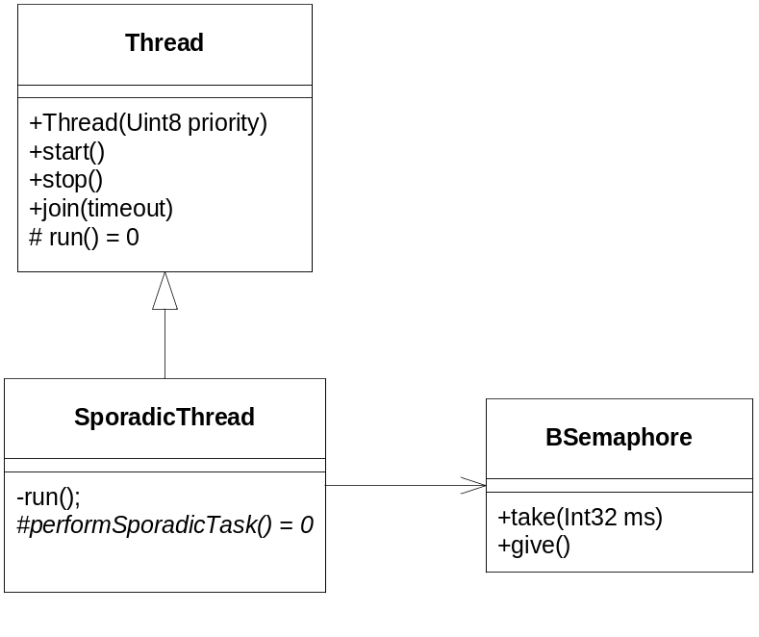
The sporadic thread is blocked until some external event releases it. The thread is blocked in a binary semaphore and becomes runnable when e.g. an interrupt routine releases the semaphore.

Mutex:

